Project Design Phase-II
Technology Stack (Architecture & Stack)
Field | Details
Date | 04 November 2025
Team ID | NM2025TMID06302
Project Name | Medical Inventory Management System
Maximum Marks | 4 Marks

Technical Architecture:
The Deliverable shall include the architectural diagram as below and the information as per the table1 & table 2
Example: Medical Inventory Management for Healthcare Facilities
Reference: https://trailhead.salesforce.com/content/learn/modules/platform-development-basics

Technical Architecture Diagram:
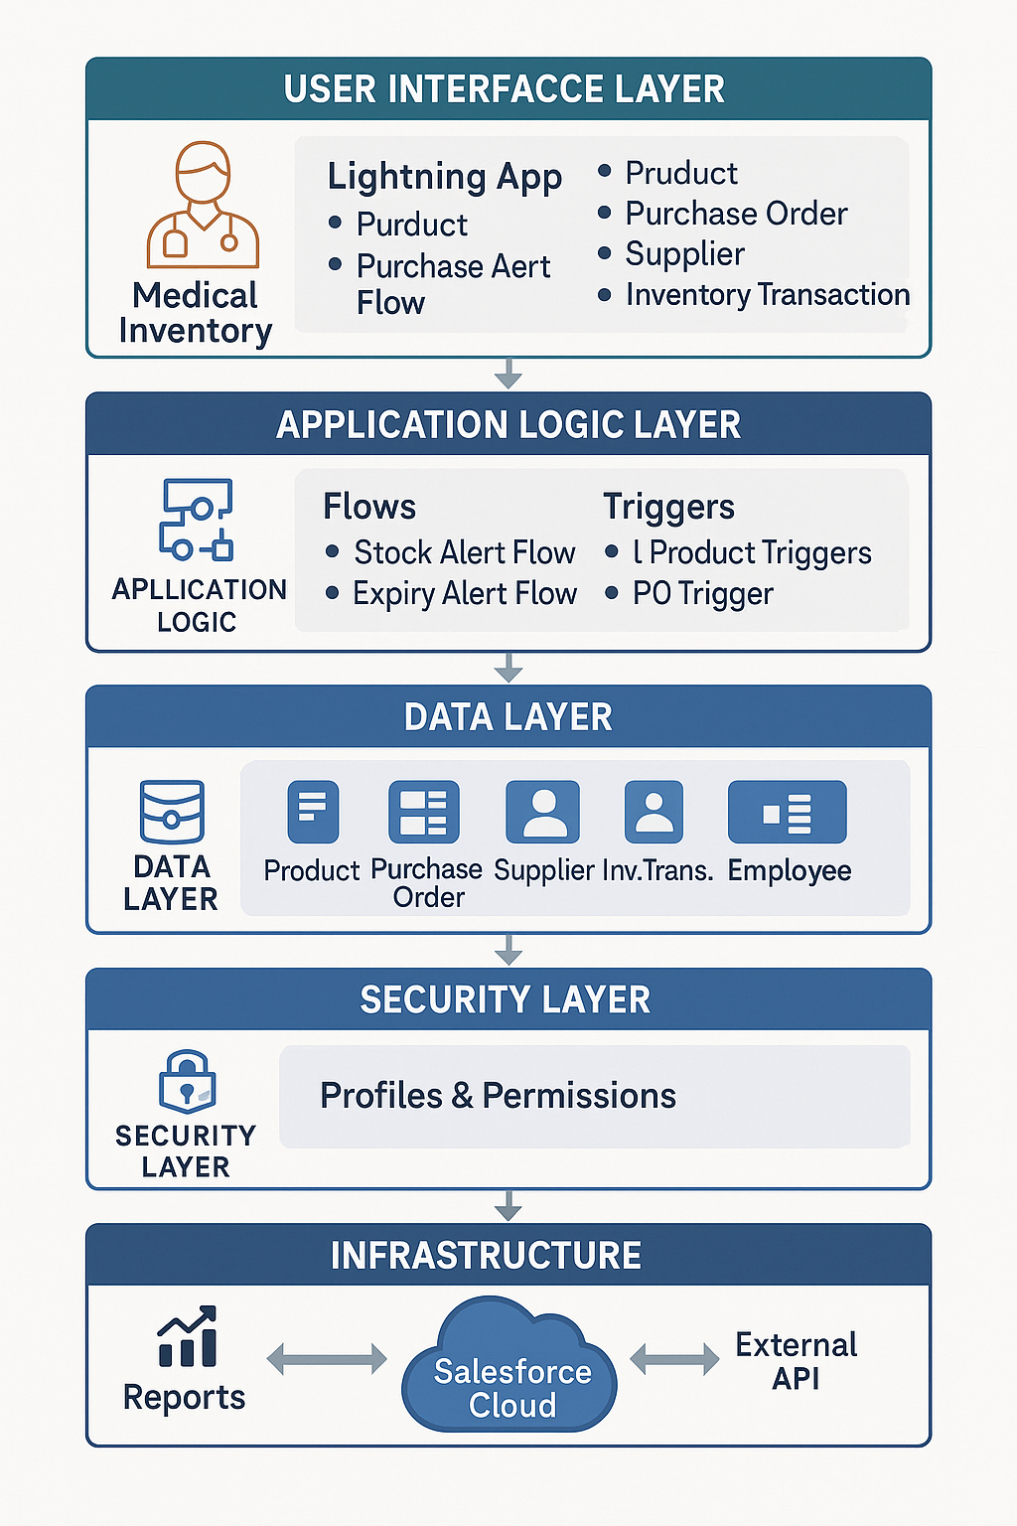
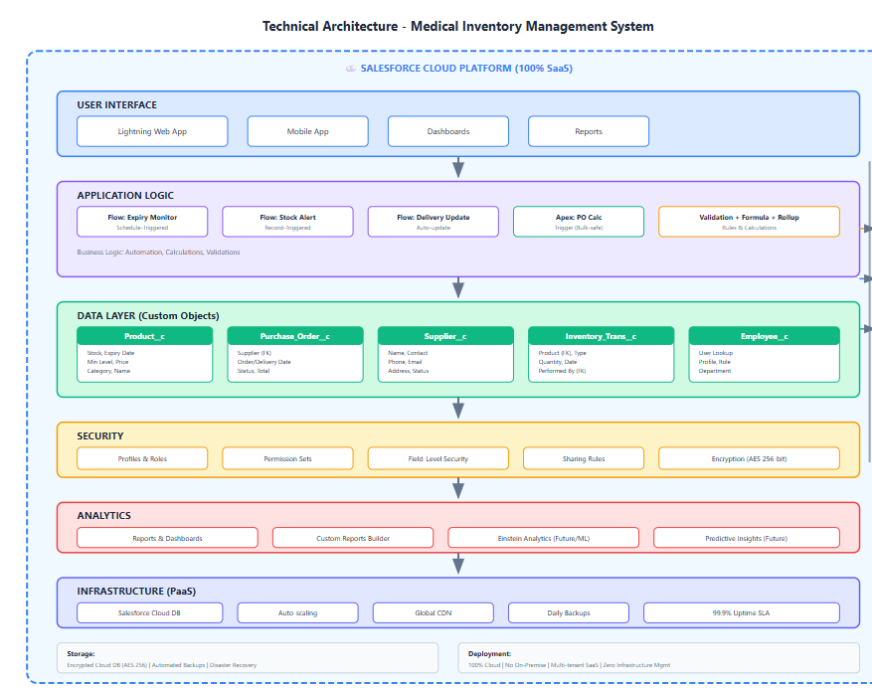
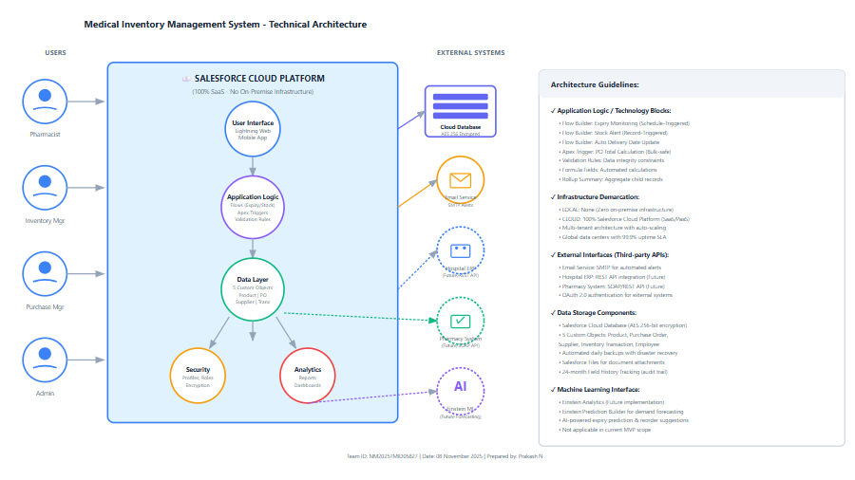
Table-1: Components & Technologies:

S.No | Component | Description | Technology
1. | User Interface | Healthcare staff (pharmacists, inventory managers, purchase managers) interact via Lightning App with custom tabs for Product, Purchase Order, Supplier, and Inventory Transaction management. Includes dashboards and reports. | Salesforce Lightning Experience (Web UI) Salesforce Mobile App (iOS/Android for warehouse)
2. | Application Logic-1 | Monitors product expiry dates daily. Sends automated email alerts at 30, 15, and 7 days before expiry to prevent dispensing expired medicines to patients. | Salesforce Flow Builder Schedule-Triggered Flow Email Alert Actions
3. | Application Logic-2 | Monitors current stock levels against minimum thresholds. Triggers alert to Inventory Manager when Current Stock < Min Stock Level with reorder recommendations. | Salesforce Flow Builder Record-Triggered Flow Decision & Assignment Elements
4. | Application Logic-3 | Automatically updates Actual Delivery Date field when Purchase Order Status changes to "Delivered". Calculates delivery variance for supplier performance tracking. | Salesforce Flow Builder Record-Triggered Flow (Before Update) Formula calculations
5. | Application Logic-4 | Automatically calculates Purchase Order Total Amount when Order Items are added, updated, or deleted. Handles bulk operations (100+ items) efficiently. | Apex Trigger (After Insert/Update/Delete) SOQL aggregation Bulk-safe processing
6. | Validation Logic | Prevents invalid data entry: Expected Delivery Date must be after Order Date, no negative stock, required fields populated. Error messages guide users. | Salesforce Validation Rules Formula expressions (IF, AND, OR) Custom error messages
7. | Formula Fields | Auto-calculates values: Line Total (Quantity × Unit Price), Days Until Expiry (Expiry_Date - TODAY()), Stock Status (if Current < Min then "Low"). | Salesforce Formula Fields Date, Number, Text functions
8. | Roll-up Summary | Aggregates child Order Item amounts to parent Purchase Order Total. Real-time updates without manual intervention. | Salesforce Roll-up Summary Fields SUM aggregation function
9. | Database - Product | Stores medicine/supply master data: Product Name, Description, Min Stock Level, Current Stock Level, Unit Price, Expiry Date. Indexed for fast search. | Salesforce Custom Object (Product__c) Encrypted cloud database Standard & Custom Fields
10. | Database - Purchase Order | Stores procurement records: Supplier (Lookup), Order Date, Expected Delivery Date, Actual Delivery Date, Status (Picklist), Total Amount (Roll-up). | Salesforce Custom Object (Purchase_Order__c) Lookup relationship to Supplier Master-Detail to Order Items
11. | Database - Supplier | Stores vendor information: Supplier Name, Contact Person, Phone, Email, Address. Related list shows all Purchase Orders. | Salesforce Custom Object (Supplier__c) Standard field types (Phone, Email, Text Area)
12. | Database - Inventory Transaction | Complete audit trail: Product (Lookup), Transaction Type (Stock In/Out - Picklist), Quantity, Transaction Date, Performed By (User Lookup). Immutable records. | Salesforce Custom Object (Inventory_Transaction__c) Lookup to Product & User Read-only after creation
13. | Database - Employee | User/staff management integrated with Salesforce User object for profile and role assignments. | Salesforce Custom Object (Employee__c) Integration with User object
14. | Cloud Database Backend | All data hosted on Salesforce multi-tenant cloud with AES 256-bit encryption, daily automated backups, disaster recovery, 99.9% uptime SLA. | Salesforce Cloud Database Encrypted at rest & in transit Global data centers
15. | File Storage | Minimal use. Stores system logs internally. Future: Attachment storage for invoices, delivery receipts, product images. | Salesforce Files, Attachments Salesforce Content Management Internal system logs
16. | External API-1 | Email service for automated notifications: expiry alerts (30/15/7 days), stock alerts (below minimum), delivery confirmations to purchase managers. | Salesforce Email Services SMTP integration Email Templates & Alerts
17. | External API-2 | (Optional future) Hospital ERP integration for financial reconciliation, patient billing, budget tracking via REST API with OAuth 2.0 authentication. | REST API in Salesforce HTTP Callouts, JSON/XML OAuth 2.0 authentication
18. | External API-3 | (Optional future) Pharmacy Management System integration for prescription-inventory linkage, dispensing records synchronization. | Salesforce REST/SOAP APIs Middleware integration Bidirectional data sync
19. | Machine Learning Model | Not applicable for current MVP. Future potential: AI-powered demand forecasting, expiry prediction based on usage patterns, optimal reorder quantity suggestions. | - (Future: Einstein Analytics, Einstein Prediction Builder)
20. | Infrastructure (Cloud) | Fully hosted on Salesforce Platform as a Service (PaaS). Zero on-premise infrastructure. Auto-scaling, load-balanced, globally distributed with CDN for fast access. | Salesforce Cloud (SaaS/PaaS) Multi-tenant architecture Auto-scaling infrastructure Global CDN

Table-2: Application Characteristics:
S.No | Characteristics | Description | Technology
1. | Open-Source Frameworks | Not applicable - Salesforce is a proprietary enterprise platform. All development uses native Salesforce tools and languages (Apex, Lightning). No external open-source dependencies. | - (Proprietary Salesforce Platform)
2. | Security Implementations | Multi-layered security: User authentication (SSO, OAuth 2.0, MFA), Role-based access control (Profiles, Roles), Field-level security (sensitive data protection), Sharing rules (record-level access), Audit trails (Field History Tracking), Data encryption (AES 256-bit at rest and in transit). | Salesforce Identity & Access Management Profiles, Roles, Permission Sets Field-Level Security, Sharing Rules Shield Platform Encryption Event Monitoring
3. | Scalable Architecture | Cloud-native SaaS architecture. Horizontally scalable via Salesforce multi-tenant infrastructure. Handles growth from 1,000 to 100,000+ products seamlessly. Supports 5 to 50+ hospital facilities with same codebase. Auto-scales resources based on demand without performance degradation. | Salesforce Multi-tenant Cloud Architecture Auto-scaling infrastructure Load balancing across global instances Distributed database architecture
4. | Availability | 99.9% uptime SLA guaranteed by Salesforce. Hosted across multiple global data centers with automatic failover. Real-time health monitoring and status dashboard. Scheduled maintenance windows with advance notification. Disaster recovery with geo-redundant backups. | Load-balanced Salesforce instances Global data center distribution Automatic failover mechanisms Real-time monitoring (Trust.salesforce.com)
5. | Performance | Optimized for enterprise-scale operations: Page load < 3 seconds, Flow execution < 5 seconds (10,000+ products), Trigger processing < 3 seconds (bulk 100+ records), Search results < 2 seconds, Dashboard refresh < 5 seconds. Asynchronous processing for heavy operations. Database query optimization with indexed fields. | Salesforce Lightning (optimized rendering) Apex Triggers (bulk-safe patterns) Flow Builder (asynchronous execution) SOQL query optimization Database indexing Queueable Apex for heavy processing
6. | Maintainability | Version-controlled development with Salesforce DX and Git integration. Modular design (Flows, Triggers, Components) allows isolated updates. Comprehensive documentation: Flow descriptions, Apex code comments, architecture diagrams. Standard naming conventions (Object__c, Field__c). Test coverage ≥75% for Apex code. Change sets for controlled deployments. | Salesforce DX (version control) Git integration (GitHub, Bitbucket) Sandboxes for dev/test/staging Change Sets, Deployment packages Apex Test Classes (75%+ coverage) Inline code documentation
7. | Interoperability | REST and SOAP APIs for integration with external systems (Hospital ERP, Pharmacy systems). Bulk API for mass data imports/exports. Email integration via SMTP. Outbound messaging for event-driven integrations. Salesforce Mobile SDK for custom mobile apps. Data export to Excel/CSV for analysis. | Salesforce REST & SOAP APIs Bulk API (CSV import/export) Outbound Messages Platform Events (pub/sub) Email Services (SMTP) Salesforce Mobile SDK
8. | Compliance & Regulatory | HIPAA-ready platform with BAA (Business Associate Agreement) available. SOC 2 Type II certified. ISO 27001 certified. GDPR compliant with data residency options. Complete audit trails for regulatory compliance (FDA, healthcare regulations). Data retention policies configurable (7+ years for purchase records). | Salesforce Shield (HIPAA compliance) Field Audit Trail (24-month history) Event Monitoring logs Data Residency (region selection) Compliance certifications (SOC 2, ISO 27001)
9. | Recoverability | Automated daily backups by Salesforce. Recycle Bin retains deleted records for 15 days. Field History Tracking for 24 months (with Shield). Weekly data export recommended for additional safety. Point-in-time recovery available through Salesforce support. Metadata version control via Salesforce DX. | Salesforce automatic backups Recycle Bin (15-day retention) Field History Tracking Weekly Data Export Service Salesforce DX snapshots
10. | User Experience (UX) | Modern, responsive Lightning interface with drag-drop customization. Mobile-optimized for iOS/Android access. Color-coded dashboards (Red: Critical, Yellow: Warning, Green: OK). Intuitive navigation with Lightning App navigation bar. Quick actions for common tasks. Global search across all objects. Contextual help and tooltips. | Salesforce Lightning Experience Lightning App Builder (drag-drop) Lightning Web Components Salesforce Mobile App Dynamic Forms, Path, Actions Einstein Search
11. | Deployment Model | Cloud-only (SaaS). No on-premise installation required. Access via web browser (Chrome, Firefox, Edge, Safari) and mobile apps. Automatic platform updates (3 releases/year by Salesforce). Zero infrastructure management overhead. Instant provisioning of new users/orgs. | Salesforce Cloud (100% SaaS) Browser-based access Salesforce Mobile App Automatic platform updates Centralized administration
12. | Cost Model | Subscription-based pricing per user per month. No upfront infrastructure costs. Includes platform, storage, security, backups, updates. Scalable licensing (add/remove users as needed). Developer Edition free for development/testing. Additional costs: Extra storage, Shield encryption, Einstein Analytics (optional). | Salesforce User Licenses Subscription model (monthly/annual) Developer Edition (free) Usage-based pricing for add-ons

